**Nearshore Marine Monitoring Hui** [name subject to change]

***Goal –***

Develop, implement, and support a database of combined coral reef monitoring datasets for Hawaii that will: live and grow at DAR; be used to develop measurements of reef status and trends to support reef management decisions statewide, and; measure our progress toward the Sustainable Hawaii Initiative goal to effectively manage 30% of our nearshore ocean waters by 2030.

***Background –***

As addressing the issues facing our oceans become ever more important, several initiatives in Hawaii are underway. In 2014, the Hawaiian voyaging canoe, Hōkūle‘a, began a worldwide voyage, and as the canoe set sail several Mālama Honua Declarations[1] were made to initiate bold actions to improve our oceans and Island Earth. The Promise to Paeʻāina[2] is one such declaration, bringing together organizations from multiple sectors of Hawai‘i’s marine resource management community to join in meeting 5 commitments for improving the ocean environment in Hawai‘i before Hōkūle‘a’s return home in 2017. One of these commitments relates to ‘Our Livelihood’ and includes a target to:

*Systemize marine monitoring to determine healthy reefs across Hawai‘i and contribute to a centralized database for improved management.*

In concert with this process is Governor Ige’s Sustainable Hawai‘i Initiative[3], which sets concrete measurable targets for finding innovative solutions to challenges facing Hawai’i’s natural environment. This includes a commitment to “Effectively manage 30% of nearshore ocean waters by 2030”. Inclusive in the implementation of the Governor’s commitment is:

*‘Effective management’ will be grounded in collaborative science and monitoring that will contribute to a consensus of standards for measuring ecosystem health that will provide the basis for evaluating effective management*.

To this end, the Nearshore Marine Monitoring Hui has been formed to serve as an advisory council of scientists who are principally involved in marine science and monitoring of Hawaii’s nearshore waters. Organizations include: Hawai‘i Division of Aquatic Resources, University of Hawaii, The Nature Conservancy, Conservation International, Western Pacific Fishery Management Council, and NOAA, with support from the Castle Foundation.

***Strategy –***

Hawaii’s nearshore waters are some of the best-studied reefs in the world, with a number of existing underwater monitoring programs. The programs operate at a number of scales, and together provide a complementary story of Hawaii’s reef status and trends. To effectively capture and make sense of the wealth of information, a synthesis of data from existing underwater visual survey programs has been created, along with a method for combining data from different methods in statistical analyses.[4]

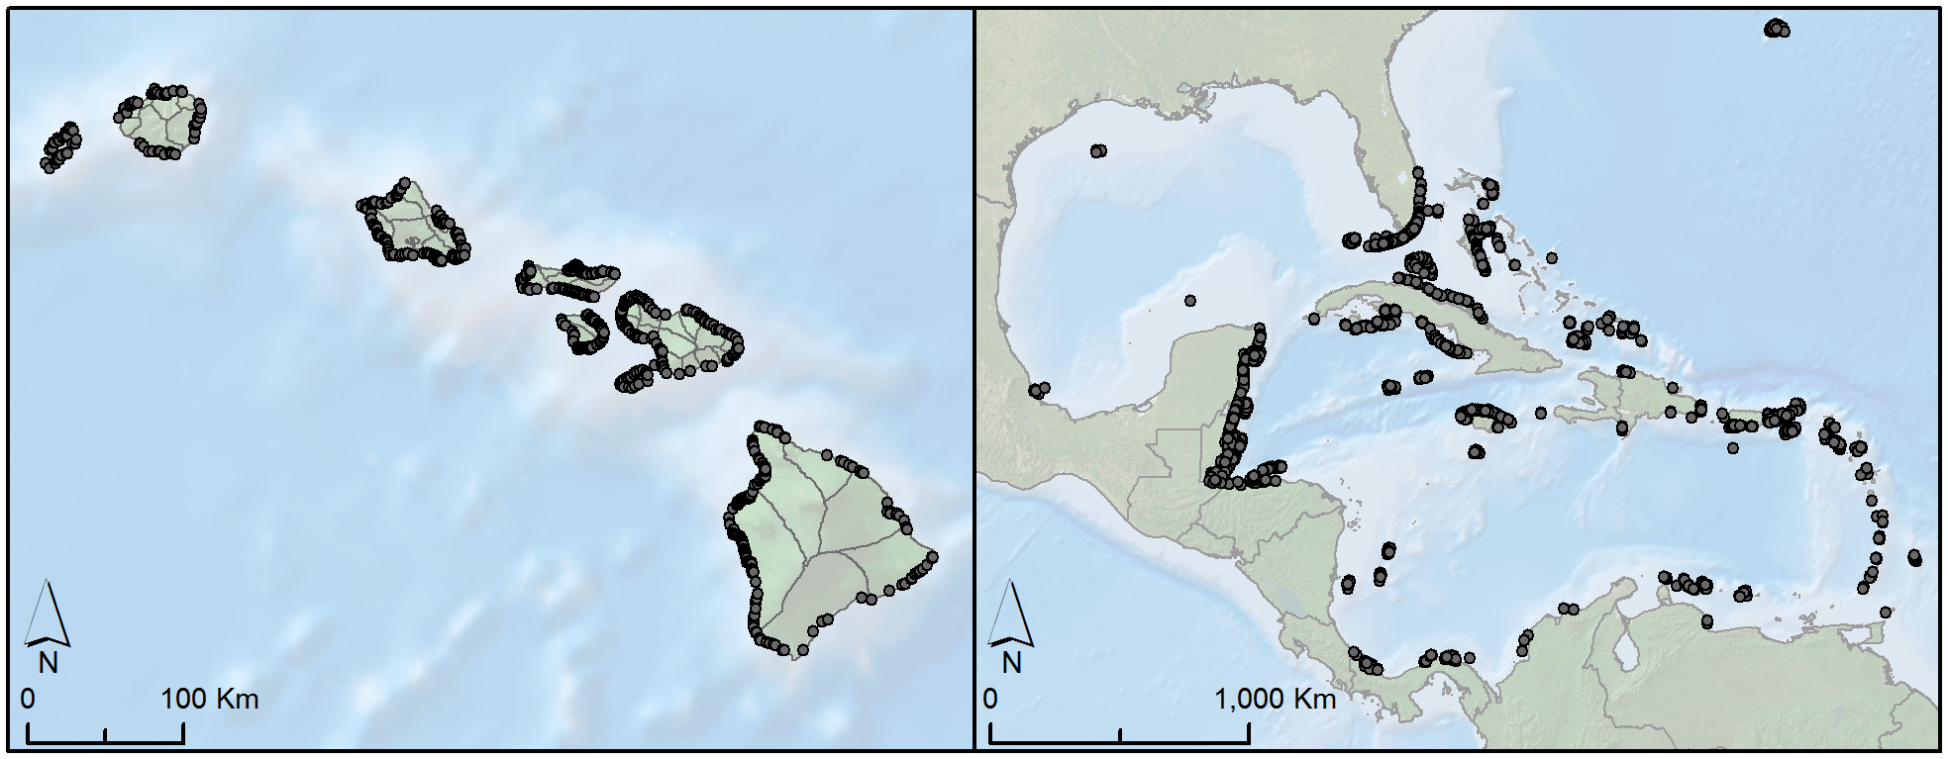

Figure 1. To date, the dataset consists of over 30,000 surveys covering the entire main Hawaiian Islands including surveys of fishes and the benthos (e.g., corals, algae, etc). This map displays the extent of the existing data (up to 2013) (grey dots), and the geographic scale (moku) that is being piloted for estimating ecological indicators of ecosystem condition (grey lines). Moku are management units from traditional Hawai‘i that were aligned to both social and ecological systems and were used for customary fisheries management.[5]

Building on this, the Nearshore Marine Monitoring Hui has the following objectives:

1. Update the synthesis of existing underwater visual surveys with recent data;
2. Develop analysis of ecological indicators for defining “functioning nearshore ecosystems” (directly relating to the task of defining “effectively managed”) that can be refined/updated and socialized more broadly;
3. Oversee the long term preservation of the dataset, create a path for systematically updating it with new data collected, and promote use of the dataset for informing current and future management decisions and policy.

[Placeholder for language/diagram couching this effort amogst the others, e.g. OHI, OTP, etc.]

1. http://www.hokulea.com/malama-honua-declarations/
2. http://www.hokulea.com/promise-to-paeaina/
3. http://governor.hawaii.gov/sustainable-hawaii-initiative/
4. Donovan, Mary (2017) PhD Dissertation, University of Hawai‘i at Mānoa
5. Malo, D (1951) Hawaiian Antiquities (Mo‘olelo Hawai‘i). Bishop Museum